PADO Quick Start Guide

# Quick Start

1. Install Pivotal’s vFabric GemFire (See the Installation section)
2. Install PADO and PADO Desktop (See the Installation section)
   1. Edit bin_sh/setenv.sh or bin_win\setenv.bat to set JAVA_HOME and GEMFIRE directory paths
   2. On Windows, run bin_win\create_shortcuts.bat to create the “PADO” and “PADO Desktop” shortcut folders on the desktop.
   3. For PADO Desktop, edit bin_sh/setenv.sh or bin_win\setenv.bat to set CODEBASE_URL. It must be in the URI format. Use the following as an example. Make sure to end it with a ‘/’.

@set CODEBASE_URL=file:///C:/Pado/pado-desktop_1.0.4-B1/

1. License Keys

Pado Open Source Edition does not require license keys. You can run as many servers and grids as you wish. You may need Pado Desktop and GemFire license keys, however.

* 1. GemFire license keys: PADO runs on top of GemFire, which may require valid license keys for commercial applications. The GemFire license keys should be added in etc/server.properties.
  2. PADO Desktop license key: The Pado Desktop license key is required and distributed by Netcrest Technologies, LLC. Please contact [support@netcrest.com](mailto:support@netcrest.com) for licenses. The Pado desktop license key should be placed in pado-desktop_<version>/etc/pado.properties.

1. Running PADO
   1. Linux

|  |  |
| --- | --- |
| cd bin_sh | Contains Unix scripts. |
| ./start_site -locators | Starts the default site, i.e., “us”. |

* 1. Windows

|  |  |
| --- | --- |
| cd bin_win | Contains Windows scripts. |
| start_site -locators | Starts the default site, i.e., “us”. |

* 1. Windows Shortcuts
     1. Open the “PADO” shortcut folder
     2. Double click on the “ny” icon
     3. From the “ny” directory, double click on the “Restart ny” icon to start the “ny” site.

# System Requirements

PADO is powered by Pivotal’s vFabric GemFire, which runs on the GemFire supported platforms as listed below. For details, please see *GemFire User’s Guide*. Note that for development, PADO can run on any platform that supports Java.

## Hardware

* x86
* x64
* SPARC

## Operating Systems

* Windows
* Linux (RHEL, SLES, Ubuntu)
* Solaris

## Software

PADO requires the following software:

* Pivotal’s vFabric GemFire 7.x, 8.x.

# Installation

To install PADO, follow the steps below:

1. Download the following distribution files:

|  |  |
| --- | --- |
| File | URL |
| PADO Binary Distribution  PADO Desktop  PADO Eclipse plug-in | <http://netcrest.com/download> |
| Pivotal vFabric GemFire | <https://network.pivotal.io/products/pivotal-gemfire> |

Note: The PADO Binary Distribution is identical to the Pado Open Source Edition available from <https://github.com/netcrest/pado>. The Netcrest's download site provides binary distributions only. If you wish to build Pado yourself or require the latest Pado source code then please download Pado from GitHub instead.

1. Install the downloaded GemFire distribution file in your file system.
2. Unzip the downloaded PADO distribution file in your file system. This will create the directory structure shown below:

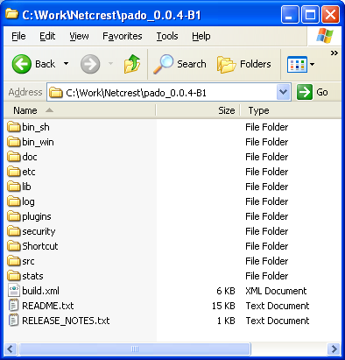

1. Unzip the download PADO Desktop distribution file in your file system. This will create the directory structure shown below:

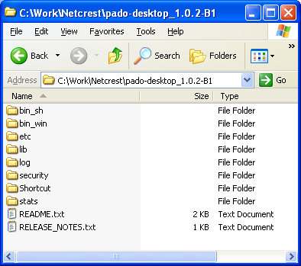

1. Unzip the Eclipse plug-in distribution file, pado-eclipse-<version>.zip, in the Eclipse root directory. Alternately, you can place the jar file found in the zip file in the eclipse/dropins directory. You must restart Eclipse to see the plug-in.

# Initial Setup

The scripts found in the bin_sh and bin_win directories manage and run PADO and PADO Desktop. Both directories contain scripts that are functionally identical except that the Windows scripts operate only on *localhost* whereas the Unix scripts operate on localhost and remote servers. Otherwise mentioned, all examples presented hereafter use the bin_sh scripts. For Windows, use the counterpart scripts.

Once PADO has been installed, follow the steps below to set the correct paths. Exception for the ssh-auto login step, these steps also applied to PADO Desktop.

## Windows

1. cd pado\bin_win
2. <Edit setenv.bat and set the correct paths for the environment variables, JAVA_HOME, GEMFIRE, and CODEBASE_URL>
3. create_shortchuts.bat -- This command creates a shortcut folder named “PADO” on your desktop. The folder contains commands that you can double click on to quickly start and stop PADO servers.

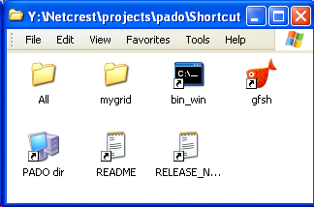

## Unix

1. cd pado/bin_sh
2. <Edit setenv.sh to set the correct paths for the environment variables, JAVA_HOME and GEMFIRE>
3. The bin_sh/ directory contains numerous scripts for managing PADO sites and servers. These scripts are driven by *ssh* which requires auto-login configured to bypass the password prompt. Follow the steps at the end of pado/README.txt to setup auto-login. Note that auto-login may not be possible for Unix VMs due to the security restrictions enforced by your company. In that case, you will need to consult your system administrator to enable ssh auto-login.

# Starting PADO

Once the initial setup is complete, PADO can be launched immediately. The examples included in the PADO distribution are configured to run multiple grids, sites, and servers. Please follow the steps listed below to start PADO grids.

## Windows

You can launch all of the grids, a single grid, or a single site by double-clicking the respective command found in the “PADO” folder on Desktop. The examples are configured to run two (2) servers per site.

### Starting a single site

Double click on the “mygrid/us/Restart us” command to start the “us” site.

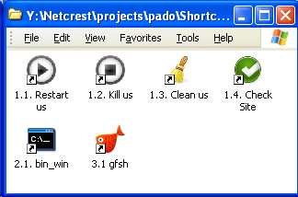

### Starting all grids and sites

Double click on the “All/Restart All” command to start all grids and sites.

### Stopping a single site

Double click on the “mygrid/us/Kill us” command to stop the “us" site.

### Stopping all grids and sites

Double click on the “All/Kill All” command to stop all grids and sites.

## Linux

### Starting the default site

cd pado/bin_sh

./start_site –locators

### Starting all sites in the default grid

./start_grid –locators

### Starting all grids and all sites

./start_all –locators

### Stopping the default site

./stop_site –locators

### Stopping all sites in the default grid

./stop_grid –locators

### Stopping all gird and sites

./stop_all –locators

### Displaying command usage

./start_server -? -- Type -? to see usage of each command

# Attaching Server Processes to Eclipse Debugger

PADO servers can be attached to Eclipse to run the debugger to step through the code in run time. Debugging is enabled or disabled as follows:

|  |  |
| --- | --- |
| bin_sh/grids/mygrid/site_<site name>.sh | Set DEBUG_ENABLED=true to enable the debugging mode. All other values disable the debugging mode. |
| bin_sh/grids/mygrid/site_<site name.sh | Set DEBUG_PREFIX to a 2 or 3 digit number that is unique within the same host. The server number is appended to this value to define the debugger port number. For example, DEBUG_PREFIX=100 will start the first server with the port number 10001, and the second server with the port number 10002, and so on. |

Once the PADO servers are running, you can attach them from Eclipse as follows:

* Select the menu, *Run/Debug* Configurations…
* From the left pane of the Debug Configurations dialog, select Remote Java Applications and select New to create a new run configuration. From the right pane, enter a PADO host and port number. The port number must be the port number of one of the servers, i.e., 10001 in the above example.
* Click on the Debug button to attach the PADO server to Eclipse’s debugger.

# Loading Mock Data

The PADO distribution includes client examples for loading mock data:

## temporal

|  |  |
| --- | --- |
| cd bin_sh/client | This directory contains example client programs. |
| ./temporal –all | Bulk-load mock temporal objects into the following paths:   * account * account_detail * bank * portfolio * position |

## pado

|  |  |
| --- | --- |
| cd bin_sh | This directory contains example client programs. |
| ./pado –dir .. | Run PadoShell. |
| /mygrid> login | Login to the default grid. |
| /mygrid> ls -lR | List all grid paths. |
| /mygrid> quit | Exit PadoShell. |

## start_gfsh

|  |  |
| --- | --- |
| cd bin_sh | Change directory to bin_sh. |
| ./start_gfsh | Start gfsh |
| gfsh>describe region –name=/mygrid/account | Displays /mygrid/account region configuration information along with the region size. |
| gfsh>query --query=”select * from /pado/acount” | Displays values in the /mygrid/account region. |
| gfsh>quit | Exit gfsh. |

# Running Demo

The PADO distribution includes demo examples to help you to quickly learn Pado features. Four our demo, run the temporal client described above to populate the grid with mocked up data as follows:

cd bin_sh/client; ./temporal –all

The above commands add 10,000 temporal objects into the grid with Lucene enabled. To view the grid content, you can use PadoShell or GemFire gfsh as follows:

bin_sh> ./pado –dir ..

/mygrid> login

/mygrid> ls -lR

/mygrid> less account

/mygrid> quit

The above command displays the contents of the temporal path, account.

The next section introduces the PADO Desktop, a GUI framework for displaying PADO-aware components. Keep the servers running so that you can use the desktop to view the grid contents.

# Starting PADO Desktop

You must login to PADO before you can access its data and services. Run the following command to start the desktop:

## Windows

* From the Pado Desktop shortcut folder, double click on the “Desktop” icon.

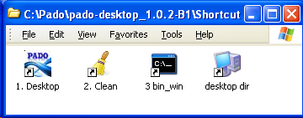

## Unix

> cd bin_sh

> ./desktop

The desktop command prompts the Login dialog. Enter locators, app ID, user name, and password in the login prompt as shown below. Authentication is disabled by default. You can enter any user name and password but you must enter the valid app ID. To run the test programs, enter “sys” or “test” for the app ID.

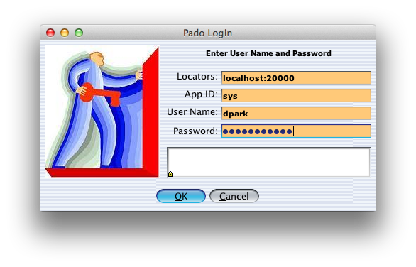

Upon successful login, if this is the first time running the desktop, then you will see an empty desktop pane as shown below.

Main Pane

Bean Bar

Select the *File/New…* menu as shown below.

Upon the menu selection, it opens a new workspace with two worksheets as shown below. Each worksheet is occupied with an empty quad in black. From the first worksheet quad right click and select the “Add Left” option from the popup menu. This option splits the quad into two quads.

Worksheet with a single quad

From the right quad, split it vertically into two by selecting the “Add Above” option to create three quads as shown below.

Quad

Worksheet

Workspace

Select the PadoInfoTreePanel from the Beanbar and click on the first quad. This instantiates the bean in the quad as shown below.

Select the ServerSearchPanel and place it in the upper right quad. For the lower right quad, place IndexMatrixPanel. Your Pado desktop should look similar to the screen shown below.

Select the *View* pulldown menu and uncheck *Show Borders* and *Show Bean Bar*. You can also dock the workspace by checking *Dock Workspace*. Upon menu selections, the desktop now appears as follows.

You can save the desktop to a file by selecting the *File/Save As…* pulldown menu. This allows you to open it later. Note that if you exit the desktop, the desktop is automatically saved so that the next time you start it, you will see the exact desktop as before.

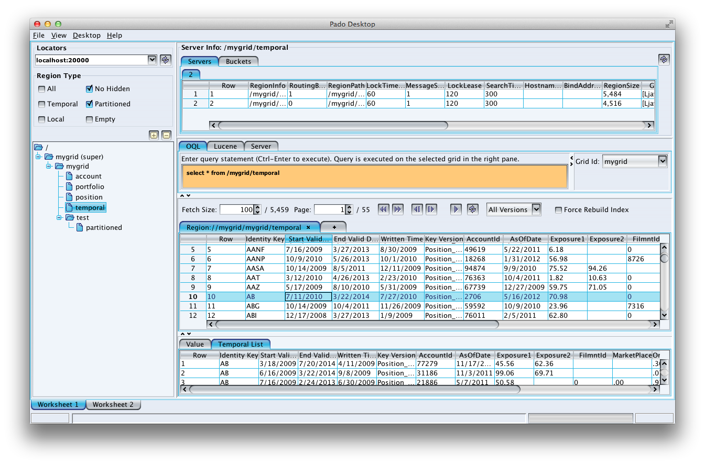

# Desktop Template

The Pado Desktop distribution includes template desktop files in the etc/ directory. The etc/template7.desktop and etc/template8.desktop templates include preconfigured screens with the core PADO management beans. If you are running JRE7 then open template7.desktop. If you are running JRE8 then open template8.desktop. The screenshot below shows the entity manager worksheet comprised of three components: TemporalEntityPanel, TemporalAttachmentPanel and TemporalPanel.

# Running Federated Grids

The example you have run so far has only one (1) grid with one (1) site. This grid is a stand-alone, self-sustained grid that has no parent and child grids. Let’s now run federated grids. Please follow the steps below.

1. First, stop *mygrid*. Make sure the mygrid locator and servers are down by executing the check_all command.

Once mygrid is completely shutdown, edit the all_env.sh or all_env.bat file and set the GRIDS environment variable as follows (The parent grid is grid0 and the rest are child grids):

GRIDS="grid0 grid1 grid2 grid3 grid4 grid5"

1. You can run one or more grids of your choice. If your machine has enough memory (~4GB) then try running all of them by executing the following command (make sure to include the –site option, otherwise, it will start all sites in each grid, which would require 3x memory):

./restart_all –locators –site us -kill

The above command first kills all running processes in the “us” site if any, cleans up the “us” log, stats, and locator files, and starts one (1) “us” locator and two (2) servers. Since there are six (6) grids, this single command will launch a total of 18 processes. Note that this command starts just a single site. If the site option is not provided, then it launches all sites, “us”, “uk”, and “jp”, or a total of 54 processes.

1. Run PadoShell to monitor the grids.

cd bin_sh; ./pado –dir ..

/> login

/grid0> grid

/grid0> grid –s

/grid0> quit

1. Launch the PADO desktop and login as before. You will now see six (6) grids in total in a single view.